Exercises: Unit Testing Classes
Submit your solutions here: https://judge.softuni.org/Contests/4492/Objects-and-Classes-Unit-Testing-Exercise

Unit Test: Student
Look at the provided skeleton and examine the Student.cs class that you will test:
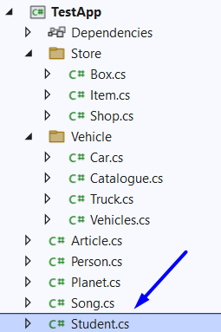
The class has properties for first name, last name, age, and hometown:
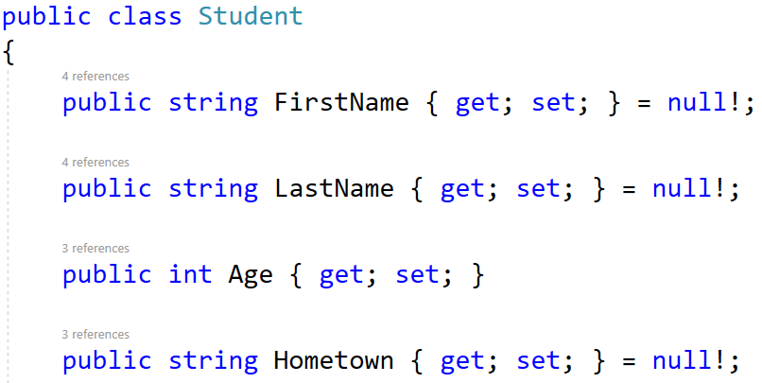
It also has a method that takes in a string array representing students in the form of:
"{first_name} {last_name} {age} {hometown}"
Also, a string representing which town the method should filter the students by and return them as a string:
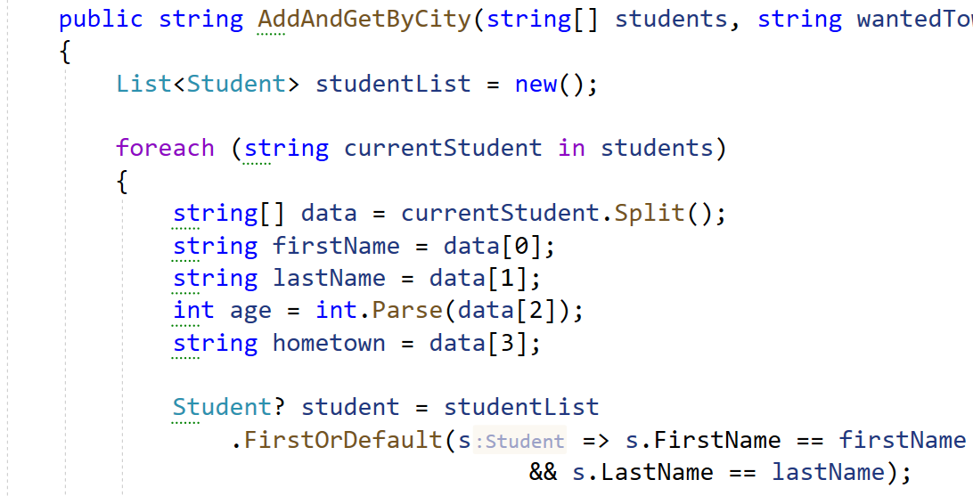
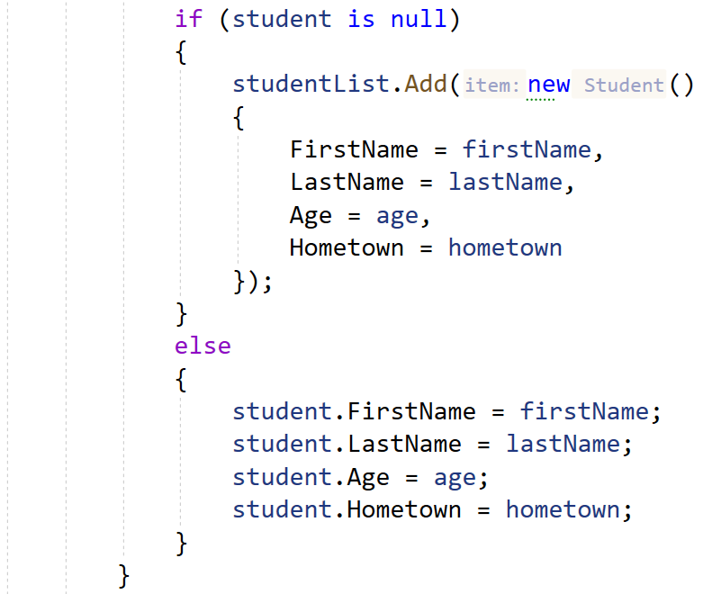
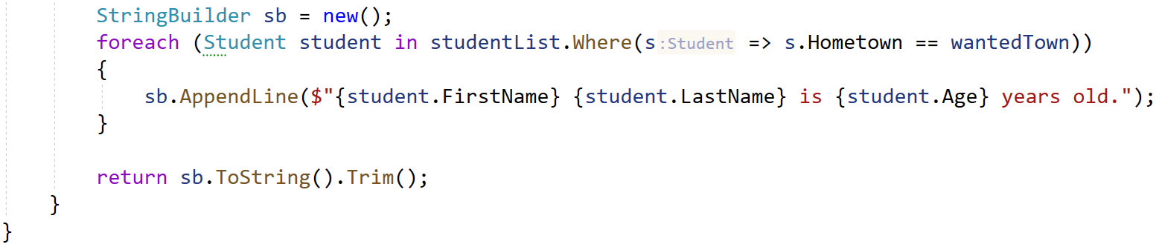
Then, look at the tests inside the StudentTests.cs class:
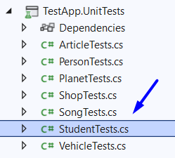
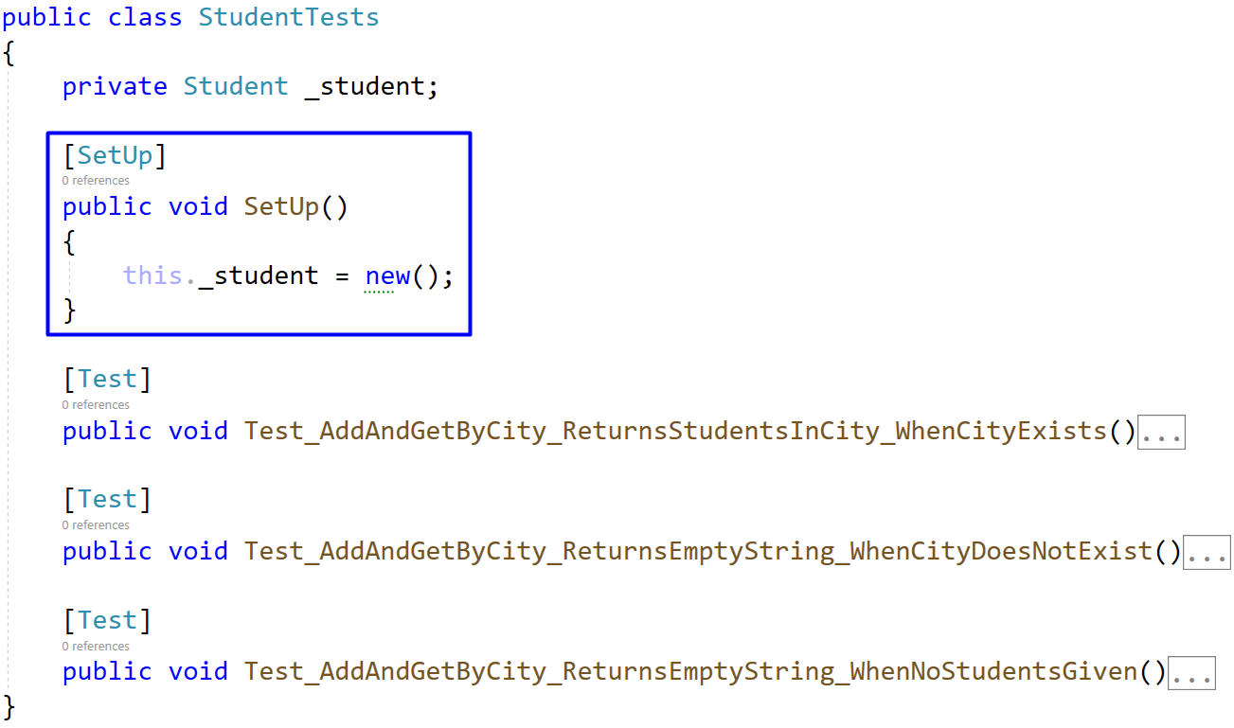
Notice the use of a setup method, so each test has a brand-new student instance to use.
The first test if partially finished so you have a reference, the rest are empty, and your task is to finish them. The tests should run when you're finished:
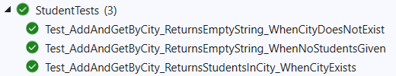

Unit Test: Song
The class Song.cs has properties for list type, name, and time:
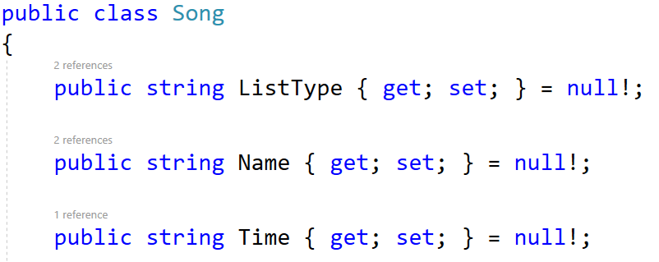
It also has a method that takes in a string array representing songs in the form of:
"{type} {name} {time}"
Also, a string representing which list (type) the method should retrieve and return each song in it as a string:
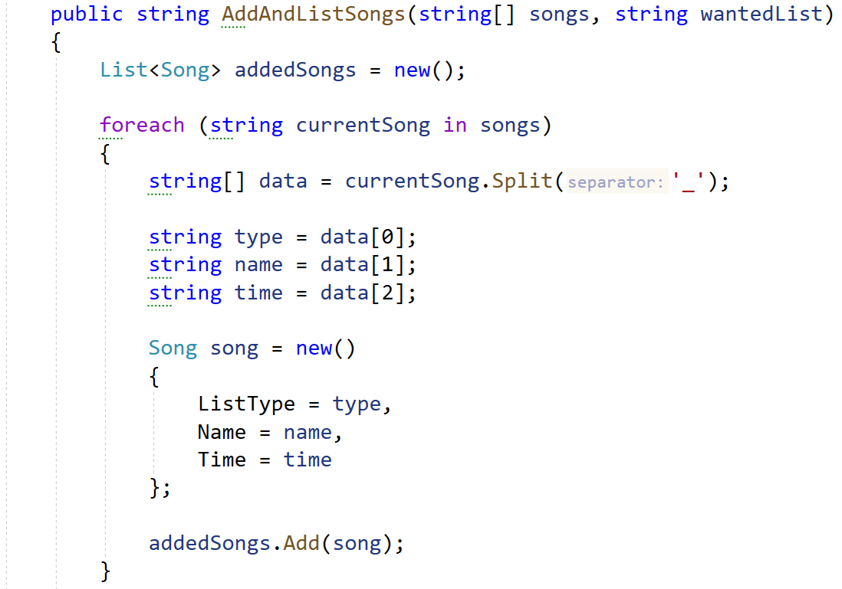
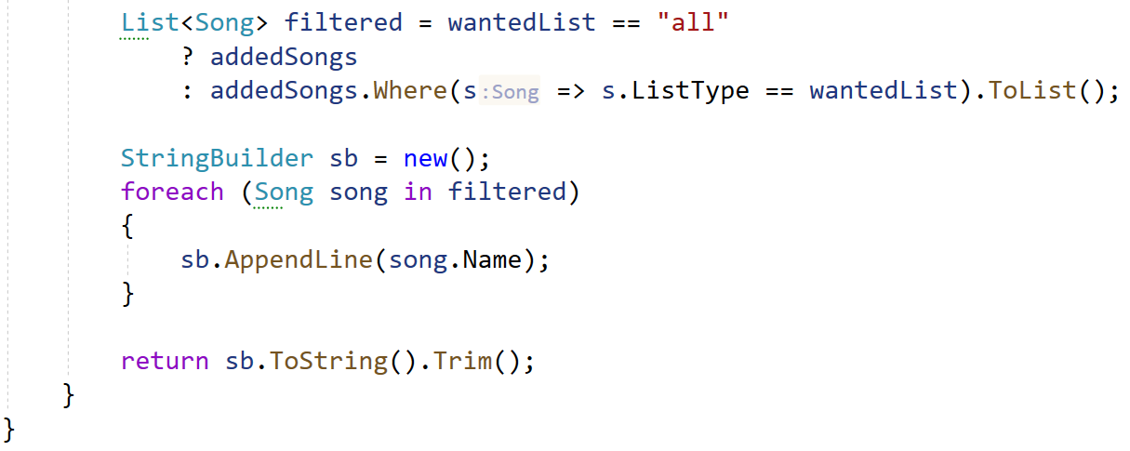
Now, look at the tests inside the SongTests.cs class:
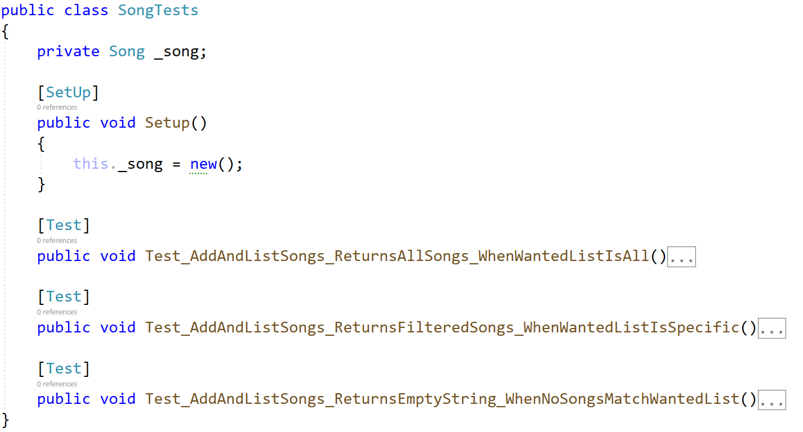
You are given a setup method again as well as one partially finished test, the rest are empty, and your task is to finish them. The tests should run when you're finished:
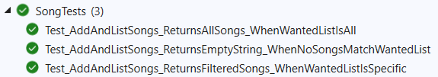

Unit Test: Store
The folder Store contains 3 classes, in which the main one is Shop.cs.
The other 2 classes are smaller classes representing real life objects only holding properties.
Box.cs:
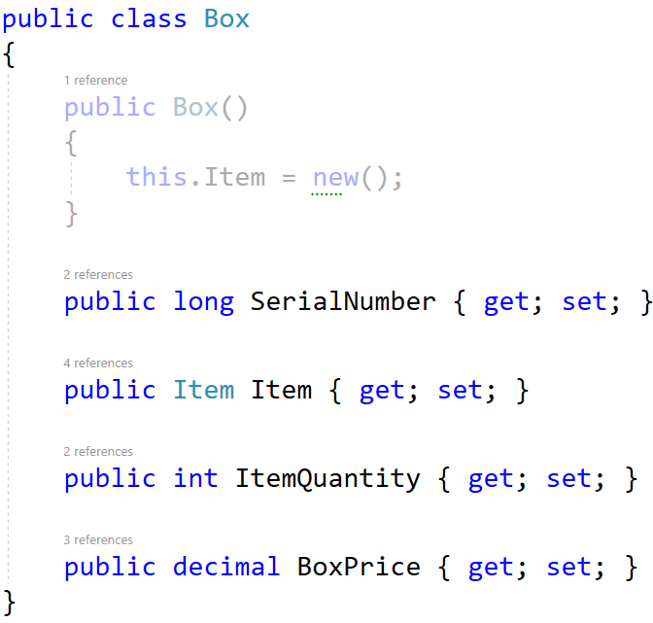
Item.cs:
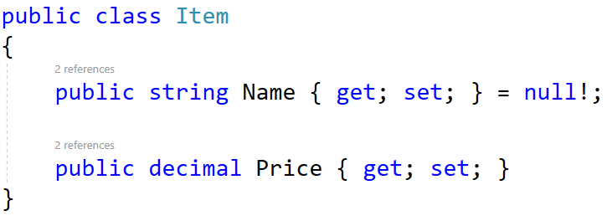
Shop.cs only has a method which takes in a string array representing products in the form of:
"{serial_number} {name} {quantity} {price}"
For each product a new Item is created and placed in a new Box then the box is added to a list. Finally, the list of boxes is returned as a string of information:
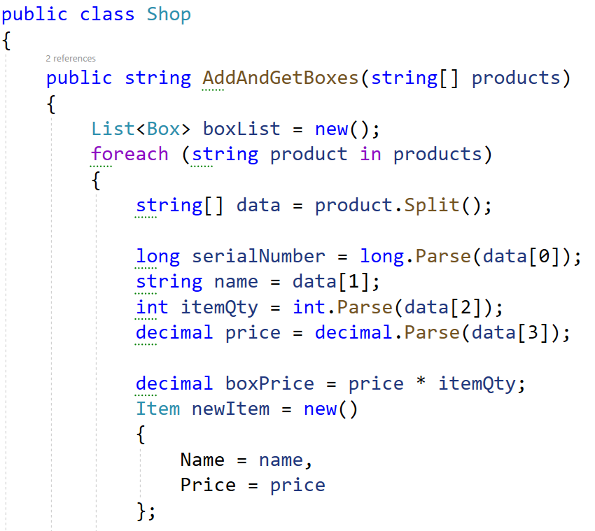
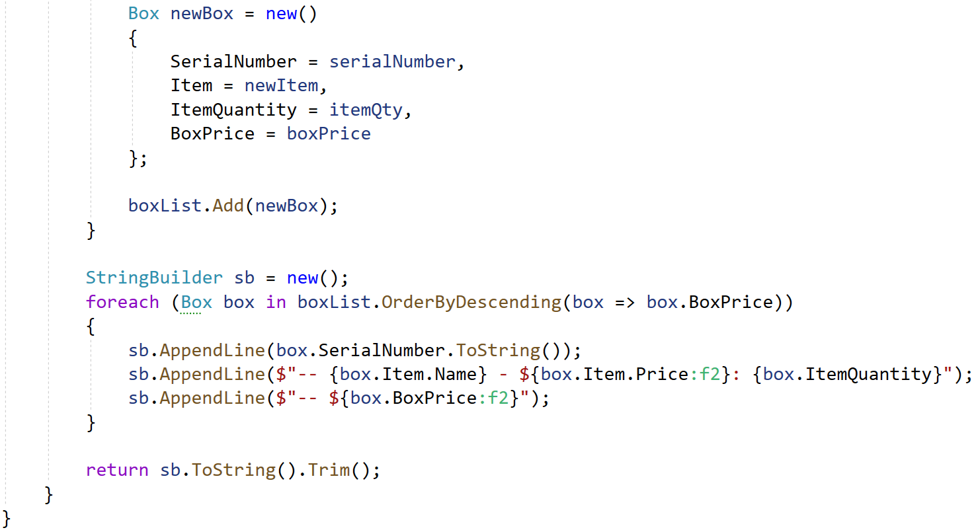Now, look at the tests inside the ShopTests.cs class:
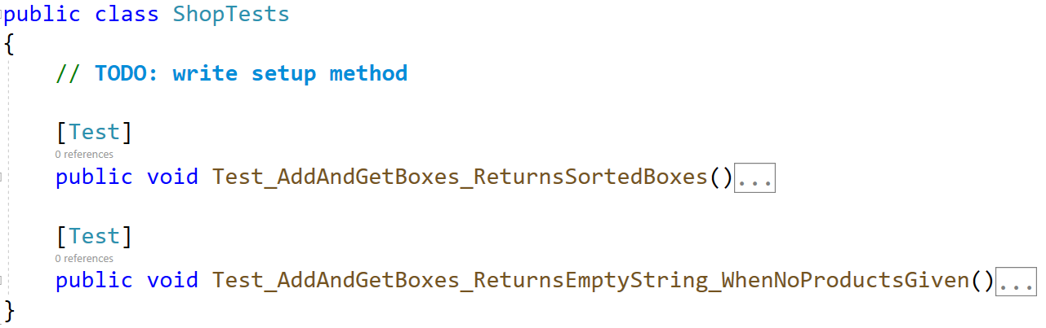
This time write the setup method on your own. You are given one partial test, the rest are empty, and your task is to finish them. The tests should run when you're finished:
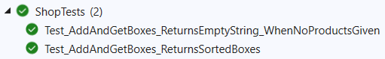

Unit Test: Vehicle
The folder Vehicle contains 4 classes, in which the main one is Vehicles.cs.
The other 3 classes represent real life objects only holding properties:
Car.cs:
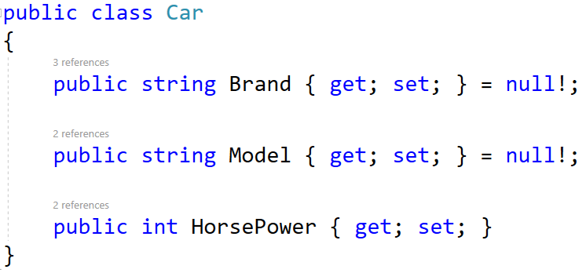
Catalogue.cs:
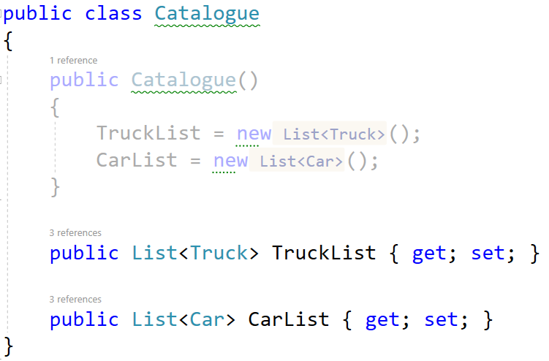
Truck.cs:
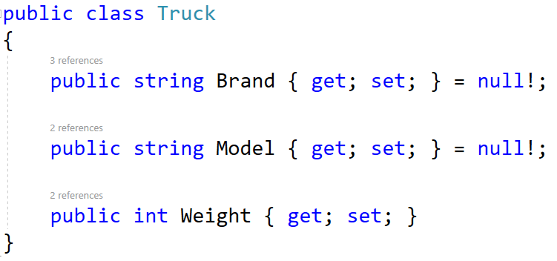
Catalogue.cs only has a method which takes in a string array representing vehicles in the form of:
"{type}/{brand}/{model}/{power}"
First, a new Catalogue is created. For each vehicle a new Truck or Car based on the type is created and added to the relevant list in the catalogue. Finally, a string is returned based on the catalogue:
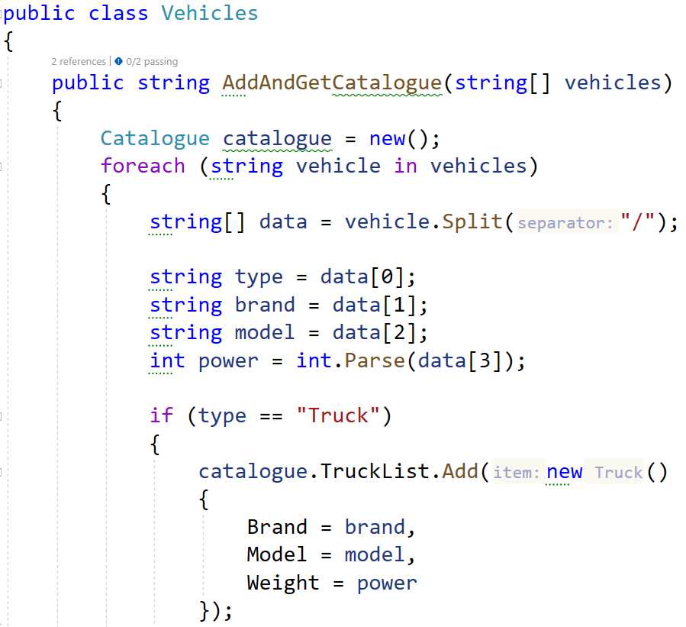
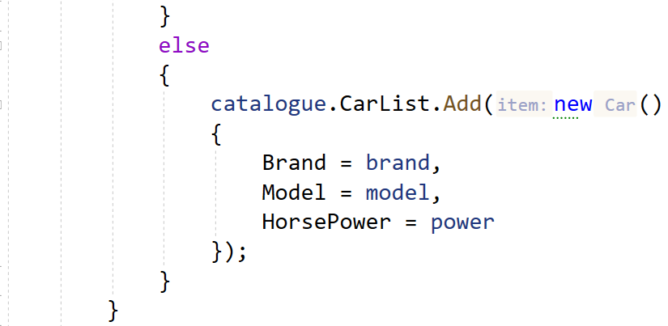
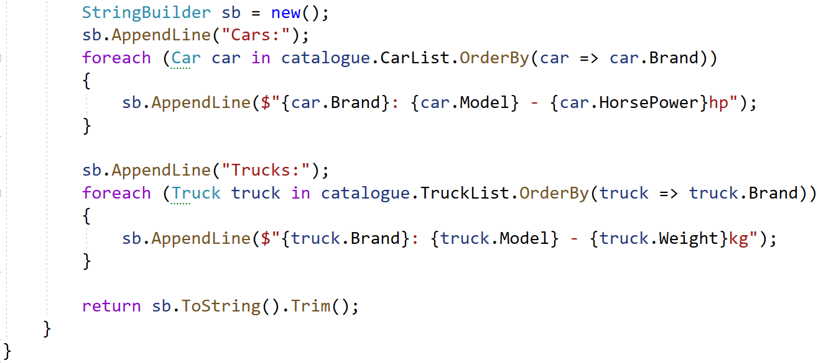
Now, look at the tests inside the VehicleTests.cs class:
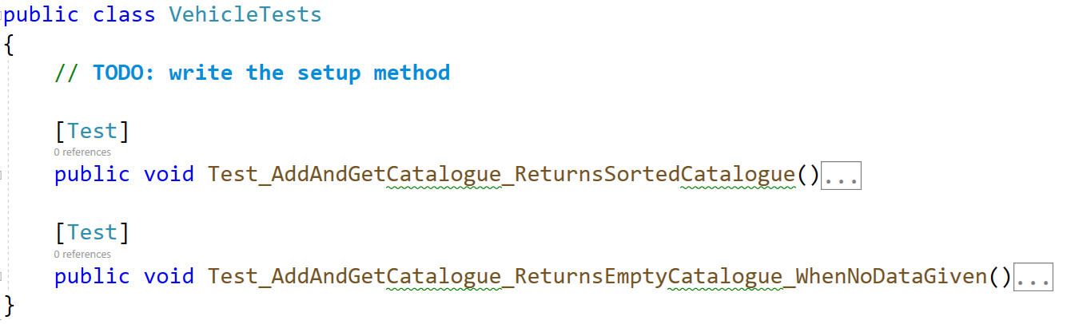
Write the setup method on your own. You are given one partial test, the rest are empty, and your task is to finish them. The tests should run when you're finished:
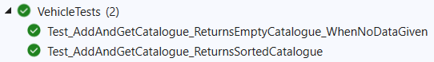

Unit Test: Person
The class Person.cs has properties for name, id, and age:
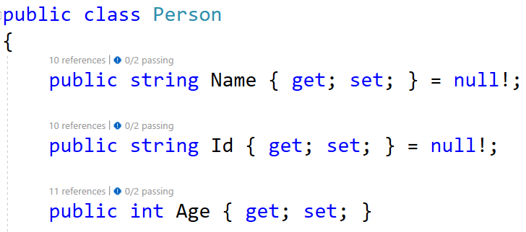
The first method it has, AddPeople(), takes in a string array representing people in the form of:
"{name} {id} {age}"
The method adds all people to a list and returns it:
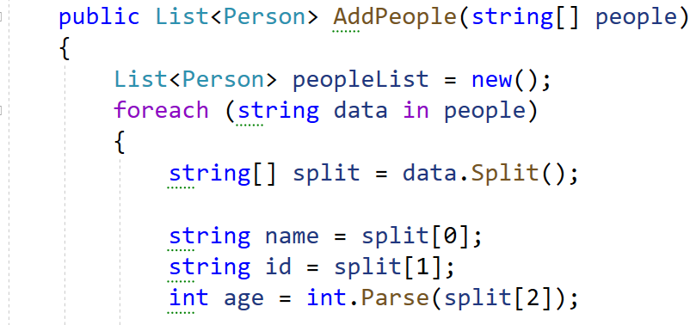
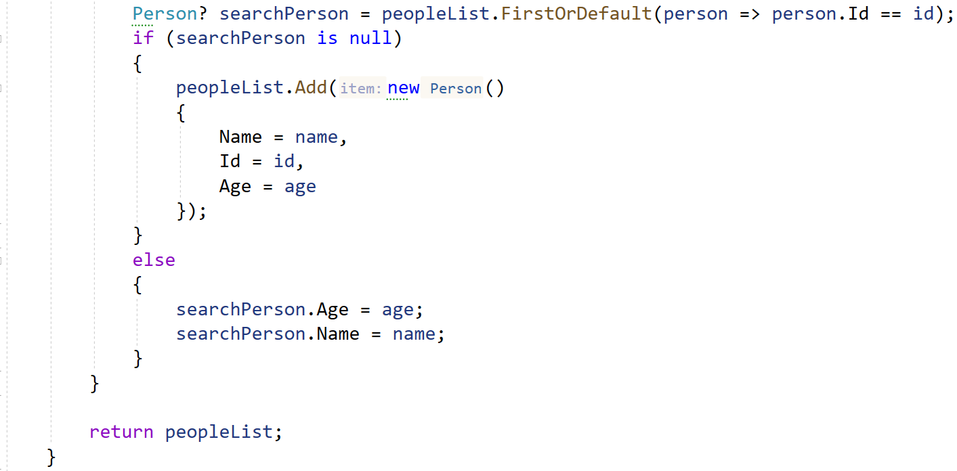
The next method, GetByAgeAscending(), takes in a list of people, sorts the list by age, and returns a string with information:
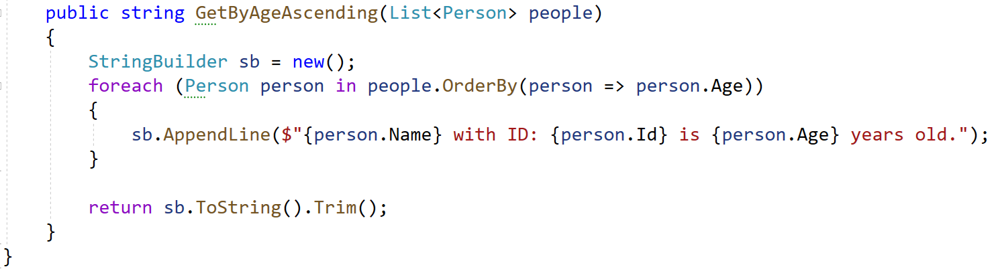
Now, look at the tests inside the PersonTests.cs class:
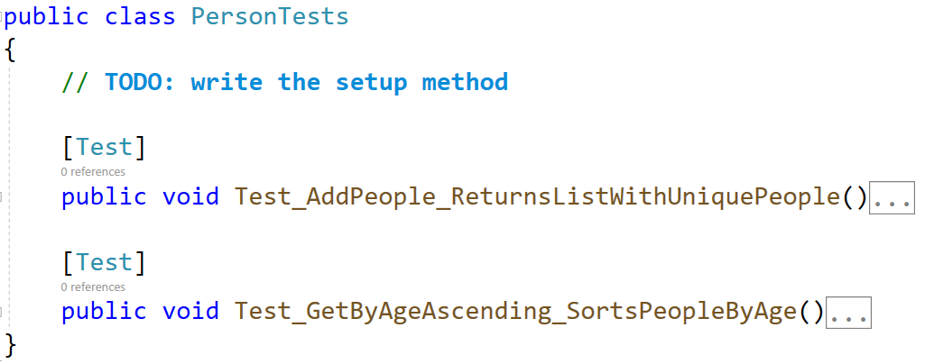
Write the setup method on your own. You are given one partial test, the rest are empty, and your task is to finish them. The tests should run when you're finished:
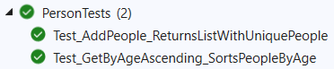

Unit Test: Article
The class Article.cs has properties for title, content, author, and article list:
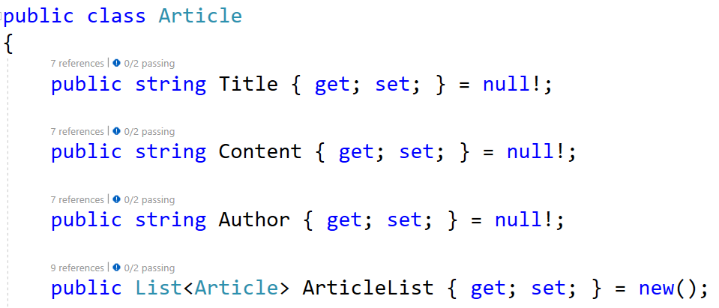
The first method it has, AddArticles(), takes in a string array representing articles in the form of:
"{title} {content} {author}"
The method adds all articles to a list and returns it:
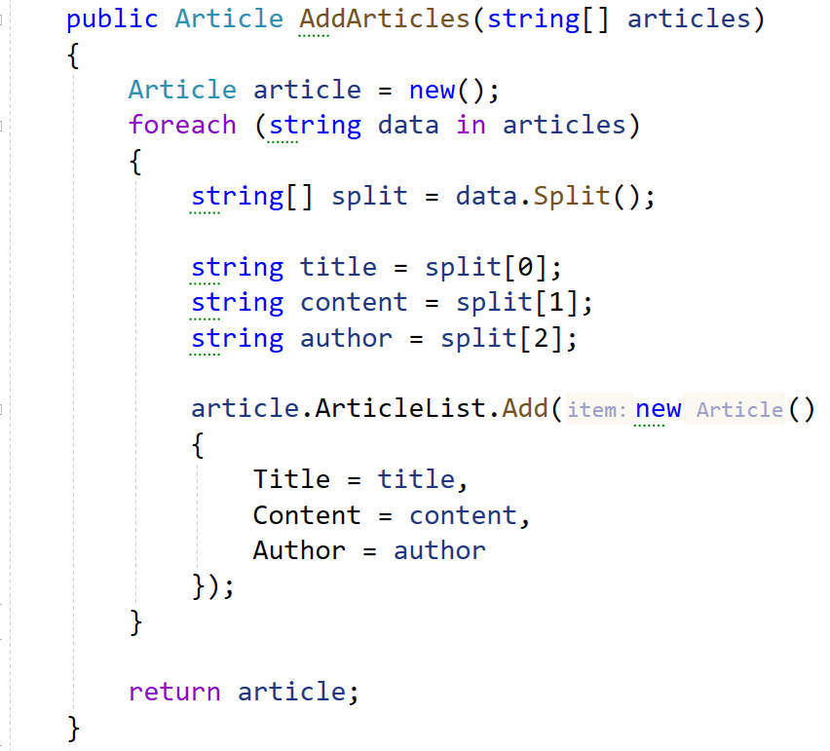
The next method, GetArticleList(), takes in an instance of an article, and a print criteria. Based on the criteria it orders the list, and returns a string with information:
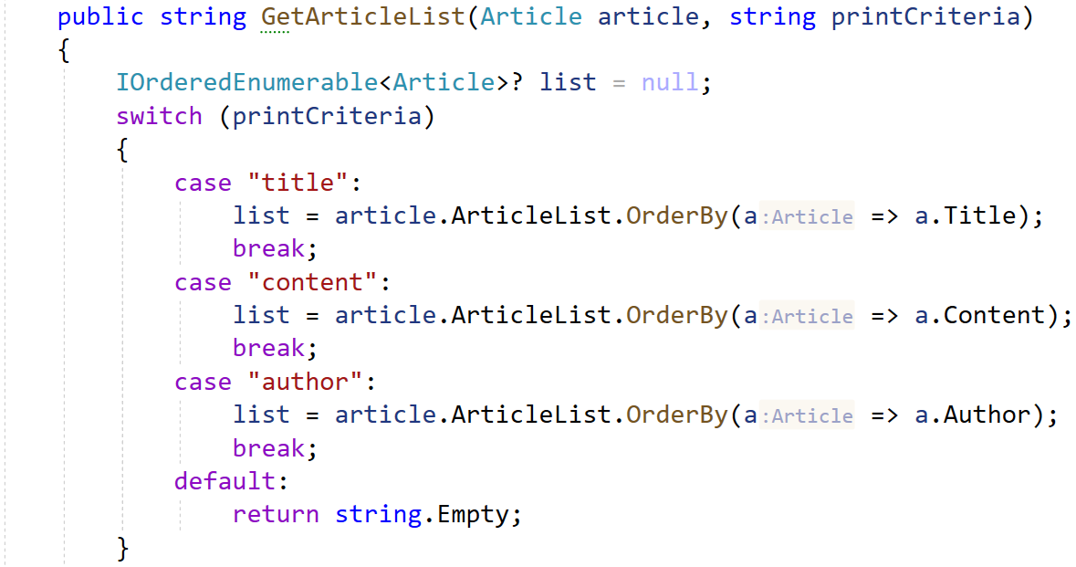
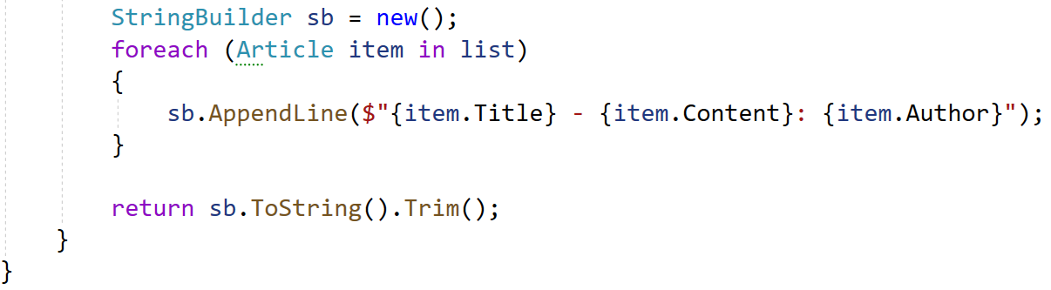
Now, look at the tests inside the ArticleTests.cs class:
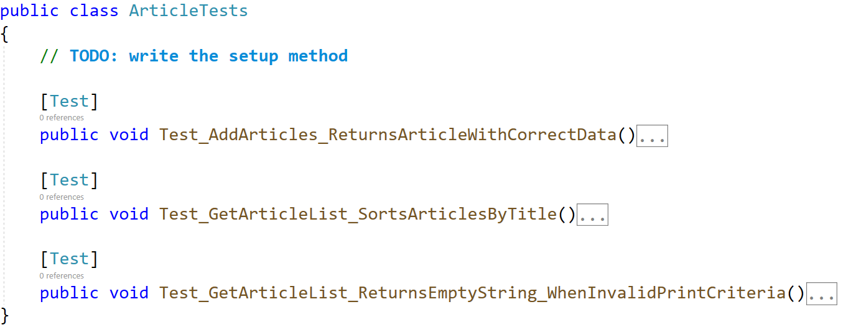
Write the setup method on your own. You are given one partial test, the rest are empty, and your task is to finish them. The tests should run when you're finished:
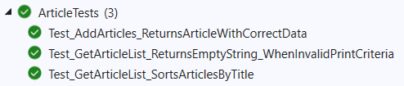

Unit Test: Planet
The class Planet.cs has properties for name, diameter, sun distance, and moon number. It also has a private field for gravitation and a constructor:
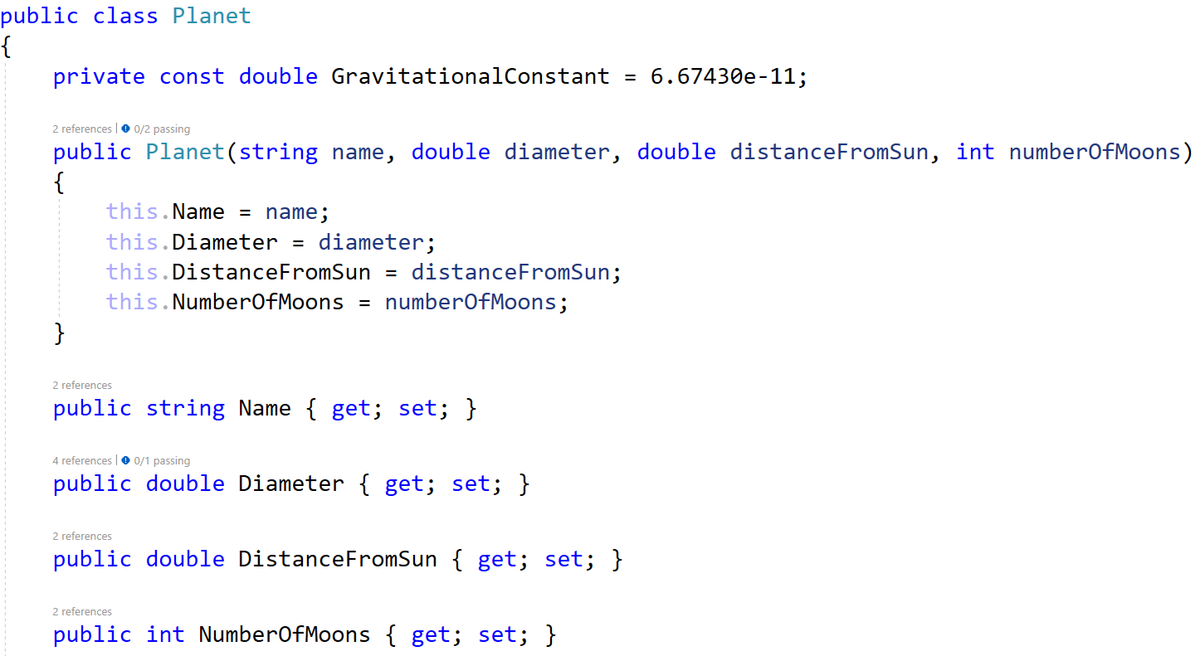
The first method it has, CalculateGravity(), takes in a number representing mass. The method calculates the planets gravity with a calculation:
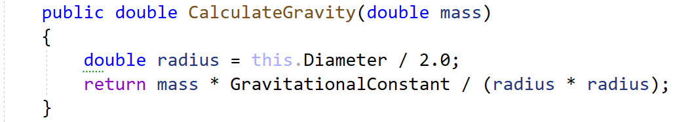
The next method, GetPlanetInfo(), returns a string with information about the planet:
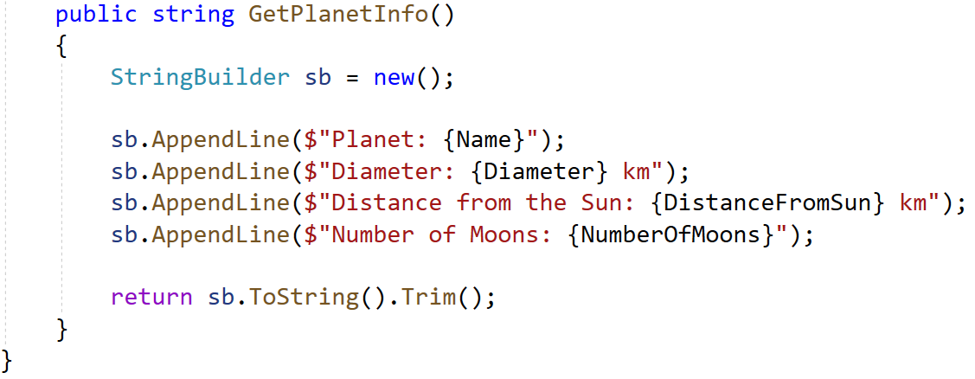
Now, look at the tests inside the PlanetTests.cs class:
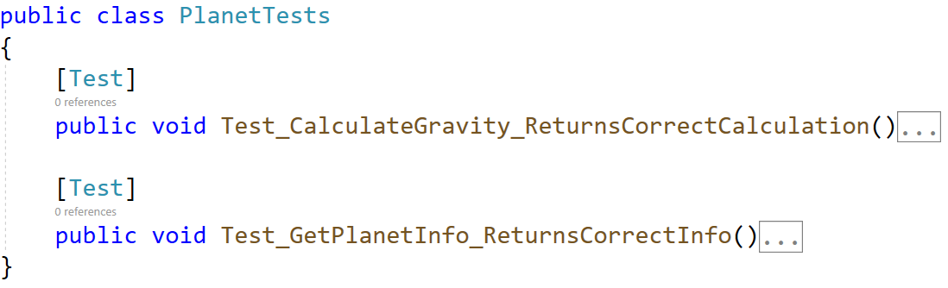
You are given one partial test, the rest are empty, and your task is to finish them. The tests should run when you're finished:
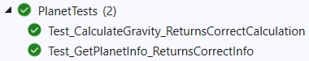
At the end make sure all tests pass:
